**Guild to Installing XCTU and Discovering XBee Radios for the Agile Robotics Control Project**

1. First install XCTU (Image of installer shown below).



1. Click “Next” on the installer window (Be sure to allow the installer to run on your computer).

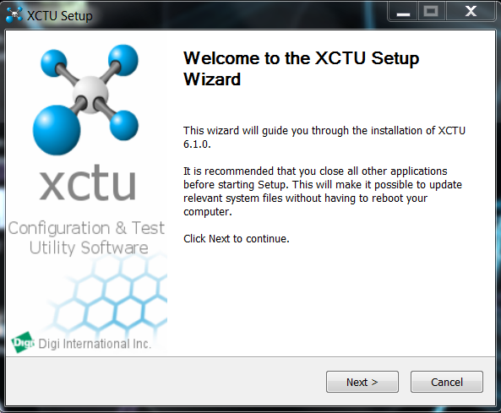

1. Click “I agree” to the license agreement (After carefully reading everything of course).

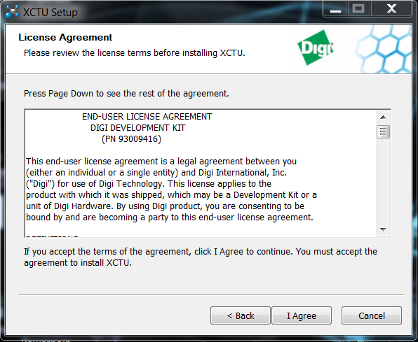

1. Click “Next”.

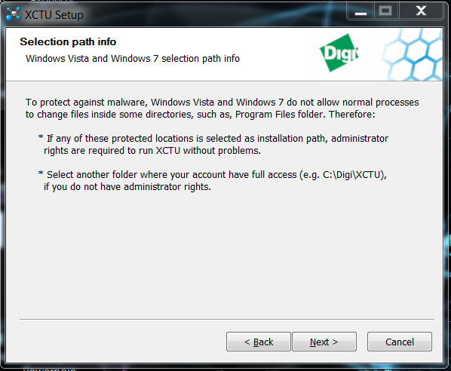

1. Select an install directory on your computer if you are not using the default. Click “Next”.

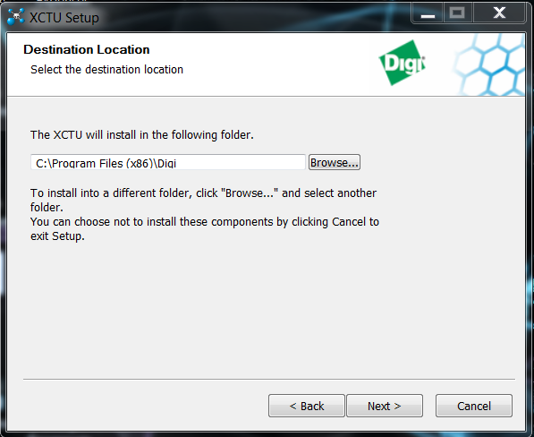

1. Click the “Install” button.

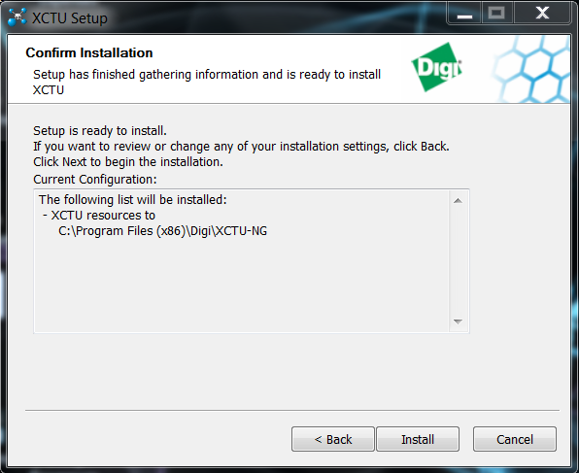

1. Wait for the installer to finish.

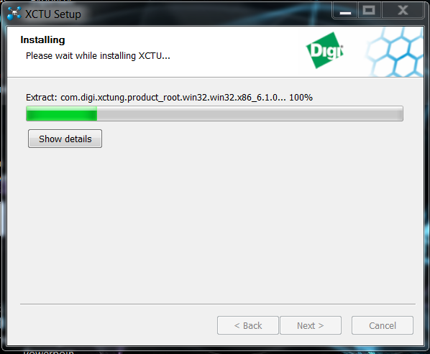

1. Click “Finish” to complete the setup wizard.

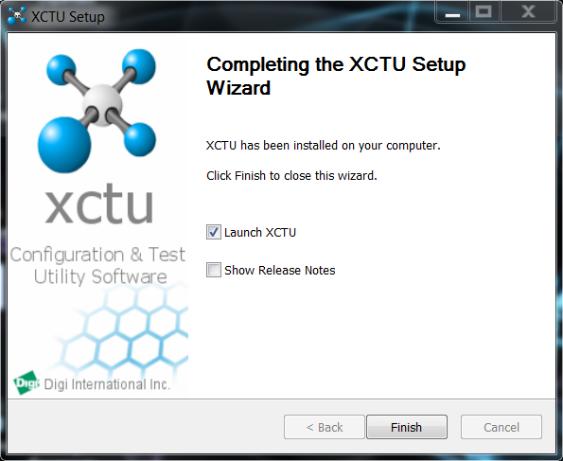

1. When finished, launch XCTU and this should come up. Click on the updates available on the bottom right corner.



1. Click “Finish”.

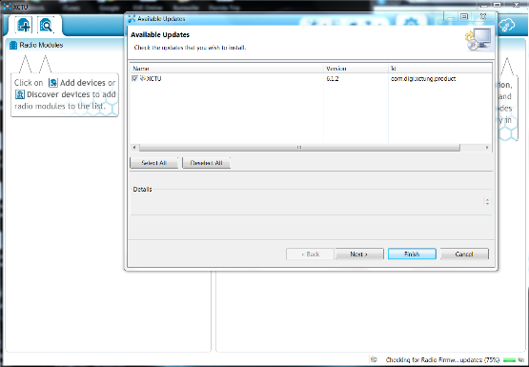

1. Wait for the update to complete.

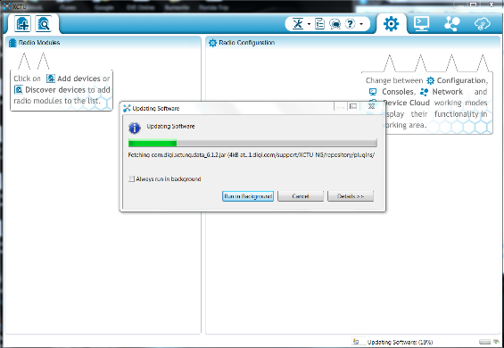

1. Click “Ok” and continue.

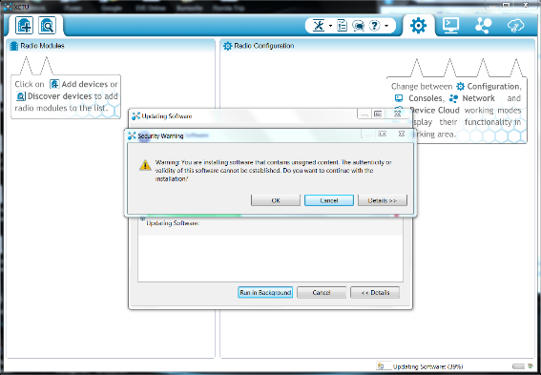

1. Restart your XCTU for the changes to take effect.

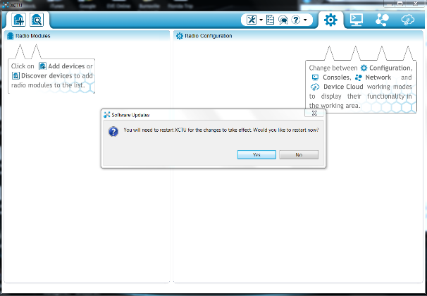

1. Install the Parallax USB driver (Image of installer shown below).



1. Click “Install” on the Parallax USB Driver Installer.

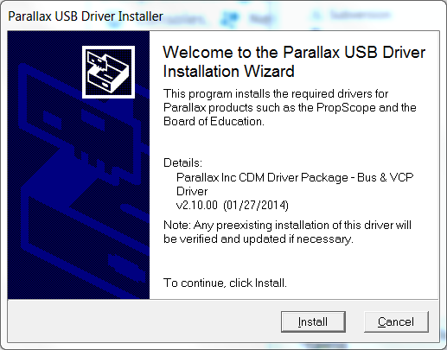

1. Click “Finish” on the Parallax USB Driver Installation.

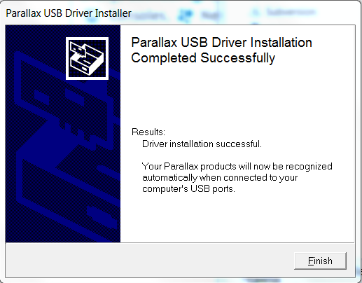

1. When finished, open XCTU and select the ports you want to scan. Click “Next”.

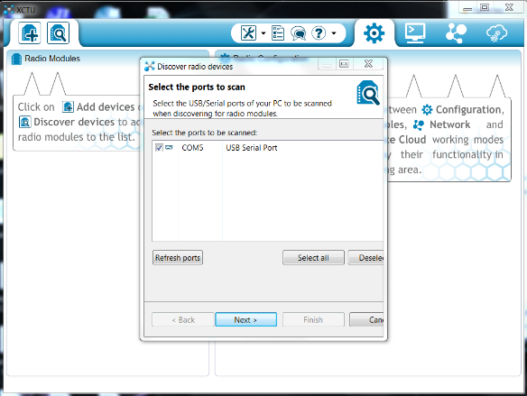

1. Follow default parameters and click “Finish”.

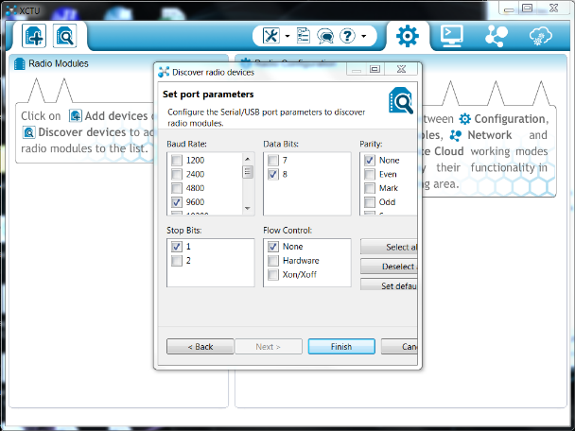

1. When the device is found, select it and click “Finish”.

